1 In this case, the task is easy, we only need to change the act function to let the bug only turn once when it can't move.
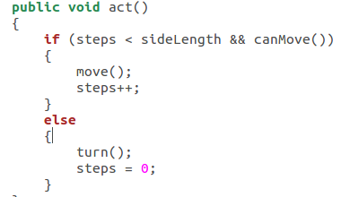

2 In such case, first we need to create a new folder, a new SpiralBug,java and a new SpiralBugRunner.java, we only need to change the act function to let the bug adjust the side length.

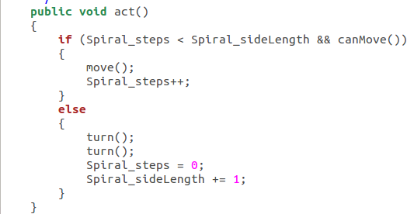
3 in this case, firstly, we need to set the direction of bug, then if the steps is the factor of the sideLength, the bug needs to turn corresponding times to run a “Z” pattern. When the bug finish a “Z” pattern, it will stop. Anf if the bug can't move, it will stop, too.
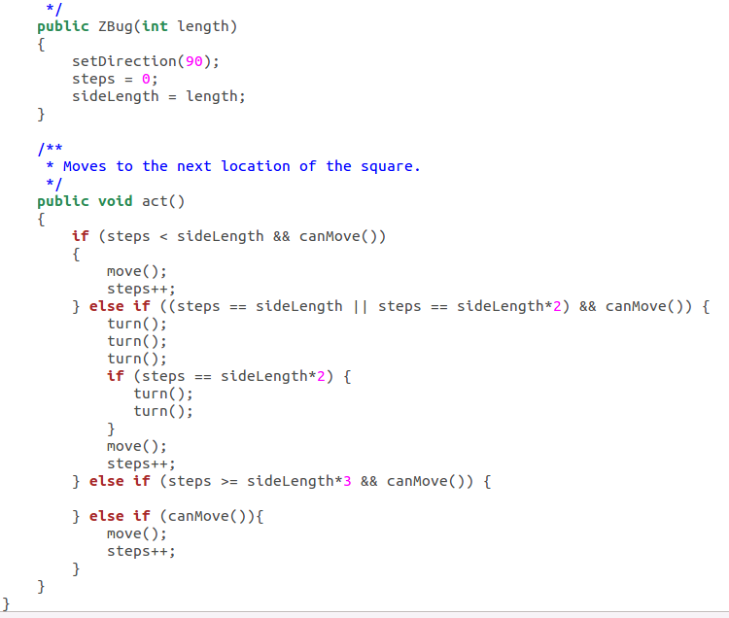
4 In this case, we need to declare some new variables, we need a num to store the length of array(generated randomly) and a array to remember each randomly generated entry, then we need a flag to judge whether the Dancingbug needs to turn(before move) or act like a normal bug, for each bug, the
num and array is different from others.

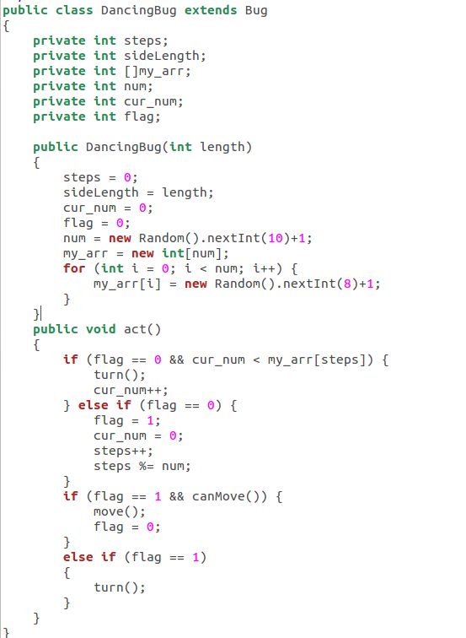
5
1 If the world doesn't exist, we need to create a new world to contain the actor and the grid and we need to finish the creation of GUI
2 If the class of new bug doesn't exist, we need to first define the behavior of the bug (the xx.bug class)
3 If the class of bug exists, we need first to new a bug object, set the direction and color and other properties of the bug
4 we need to add the bug into the world, set a valid location for the bug
5 we need to refresh the world and show the bug



